Software Requirements Specification (SRS)

Smart Mess Rental Management System

1. Introduction
Students often struggle to find available mess seats, rental houses, or suitable accommodation, while landlords and mess owners have difficulty reaching students who are looking for accommodation. The Smart Mess Rental Management System is a centralized web platform where students can search for available mess seats and rental houses, and landlords/mess owners can publish their available spaces. The platform also includes a used-product marketplace where students can buy and sell items among themselves.

2. Scope
The system will be developed as a web application using the MERN stack (MongoDB, Express.js, React, Node.js). The initial (MVP) release covers user registration and role-based access, listing creation and browsing for mess seats and rental houses, search and filtering, owner contact, and basic admin moderation. A used-product marketplace, review/rating system, and real-time notifications are planned as later-phase enhancements and are outside the MVP scope.

3. Objectives
- Provide a single centralized platform connecting students with landlords and mess owners.
- Allow students to search and filter available mess seats and rental houses by location, price, and type.
- Allow landlords and mess owners to publish and manage their listings easily.
- Provide a moderation mechanism so that admins can approve/reject and manage listings.
- Lay a foundation that can later be extended with a student marketplace, reviews, and notifications.

4. User Roles and Responsibilities
Role | Responsibilities
Student | Register/login, manage profile, search and view listings, contact listing owners.
Landlord / House Owner | Register/login, create and manage house rental listings (location, rent, facilities, images), respond to interested students.
Mess Owner | Create and manage mess listings (seats, rent, facilities, rules, location), update seat availability.
Admin | Manage users and listings, approve/reject posts, remove inappropriate content, monitor the overall system.

5. Feature List
Features are prioritized into the MVP release and later phases, based on requirement analysis with the supervisor.
Feature | Priority | Phase
User registration & login (role-based) | Must-have | MVP
Student profile | Must-have | MVP
Mess seat listing (create/view) | Must-have | MVP
House/rental listing (create/view) | Must-have | MVP
Search and filter (location, price, type) | Must-have | MVP
Student contact listing owner | Must-have | MVP
Landlord publish house listing | Must-have | MVP
Mess owner publish seat listing | Must-have | MVP
Admin dashboard (manage users/listings) | Must-have | MVP
Post approval / moderation | Must-have | MVP
Used-product buy/sell marketplace | Optional | Phase 2
Student requirement posts | Optional | Phase 2
Reviews / ratings | Optional | Phase 2
Notifications | Optional | Phase 2

6. System Architecture
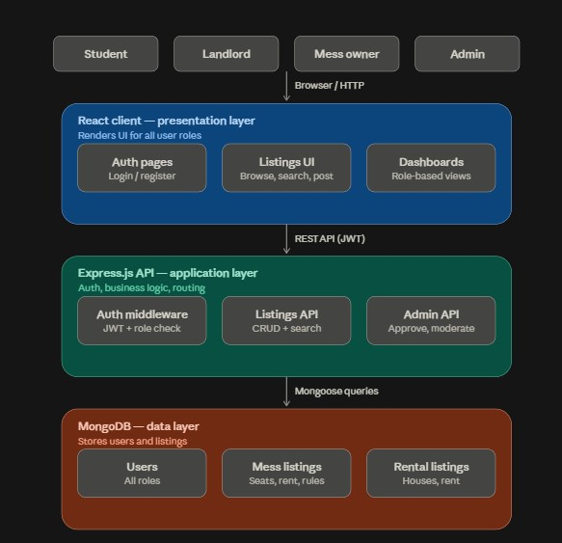
The system follows a three-tier (client-server) architecture, standard for MERN stack applications:
Layer | Description
Presentation Layer (Client) | React single-page application. Handles UI for students, landlords, mess owners, and admin. Communicates with the backend via REST API calls (Axios/Fetch).
Application Layer (Server) | Node.js + Express.js REST API. Contains route handlers, controllers, authentication/authorization middleware (JWT + role-based access), and business logic for listings, search/filter, and moderation.
Data Layer (Database) | MongoDB (via Mongoose ODM). Stores collections for Users, Mess Listings, Rental Listings, and Admin/moderation records.

- Client sends HTTP requests (login, create listing, search, etc.) to the Express API.
- Express routes validate the request, apply auth/role middleware, and call the relevant controller.
- Controllers interact with MongoDB through Mongoose models and return JSON responses.
- The client renders the response and updates the UI accordingly.

7. Time Schedule (6-7 Week Plan)
The following week-wise plan maps the initial task list to a 6-7 week development timeline.
Week | Focus | Tasks
Week 1 | Initiation & SRS | Finalize SRS, get supervisor sign-off, set up GitHub repository, branch structure & contribution guidelines, write README and initial task list.
Week 2 | Backend Foundation | Initialize Express server & MongoDB connection, design DB schema (User, Mess Listing, Rental Listing), implement authentication (register/login, JWT, role-based access).
Week 3 | Core Listing APIs | Implement Mess Listing CRUD APIs and House/Rental Listing CRUD APIs, basic admin approval/moderation endpoints.
Week 4 | Search & Frontend Setup | Implement search & filter API, initialize React app with routing/layout, build authentication pages (register/login).
Week 5 | Frontend Core Pages | Build listing creation forms (landlord/mess owner), build listing browse & search page (student view), listing detail page with contact option.
Week 6 | Admin & Integration | Build admin dashboard (approve/reject listings, manage users), integrate frontend with backend APIs end-to-end.
Week 7 | Testing & Submission | Testing and bug fixing, prepare demo, finalize documentation for submission.

8. Out of Scope (for MVP)
- Real-time chat between users (simple contact via phone/email/in-app message in MVP).
- Full report-management workflow (simple admin flag/approve in MVP).
- Payment integration.

9. Assumptions and Constraints
- Requirements may change during further requirement analysis with the supervisor.
- Development will proceed iteratively, starting with the MVP feature set.
- The 6-7 week schedule assumes MVP scope only; Phase 2 features are not included in this timeline.

10. Acknowledgement
- Frontend: React
- Backend: Node.js with Express.js
- Database: MongoDB
- Version Control: Git & GitHub

